<!DOCTYPE html>

<html>

<head>

<title>Q1</title>

</head>

<style>

body{background-image: url(stripe-hero-background-effect-html-css.png);}

</style>

<body>

<h1 style="text-align: center;">HTML is a language</h1>

<h2 style="text-align: center;">This is slightly smaller than above</h2>

<h3 style="text-align:center;">This is even smaller</h3>

<p style="text-align: center;">Hypertext markup language.</p>

</body>

</html>

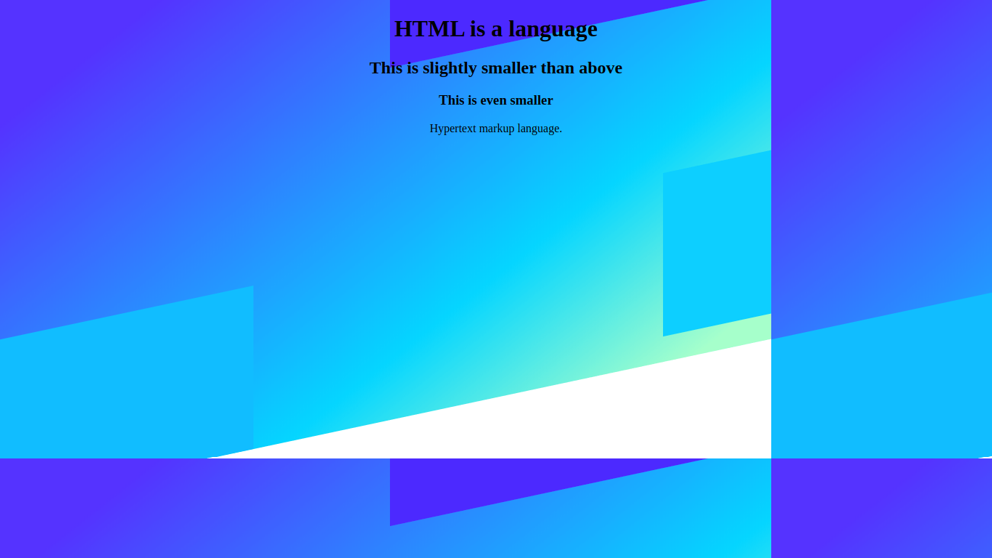

<!DOCTYPE html>

<html>

<head>

<title>Q2</title>

</head>

<body>

<h1>Basketball football basketball</h1>

<div style = " height:340px; width:340px; float:left;">

<table border="1" cellspacing="1" cellpadding="2">

<tr>

<td align=left><b>&nbsp;<img src="unnamed.png"> &nbsp;</b></td>

</tr>

<tr>

<td align=center bgcolor=F5F5F5><b>&nbsp;<p>This is a basketball</p>&nbsp;</b></td>

</tr>

</table>

</div>

<div style = " height:340px; width:240px; float:left;">

<table border="1" cellspacing="1" cellpadding="2">

<tr>

<td align=left><b>&nbsp;<img src="30946-9-soccer-football-thumb.png"> &nbsp;</b></td>

</tr>

<tr>

<td align=center bgcolor=F5F5F5><b>&nbsp;<p>This is a football</b><br>Let's kick this</p>&nbsp;</td>

</tr>

</table>

</div>

<div style = " height:340px; width:340px; float:left;">

<table border="1" cellspacing="1" cellpadding="2">

<tr>

<td align=left><b>&nbsp;<img src="unnamed.png"> &nbsp;</b></td>

</tr>

<tr>

<td align=center bgcolor=F5F5F5><b>&nbsp;<p>This is another basketball</p>&nbsp;</b></td>

</tr>

</table>

</div>

</body>

</html>

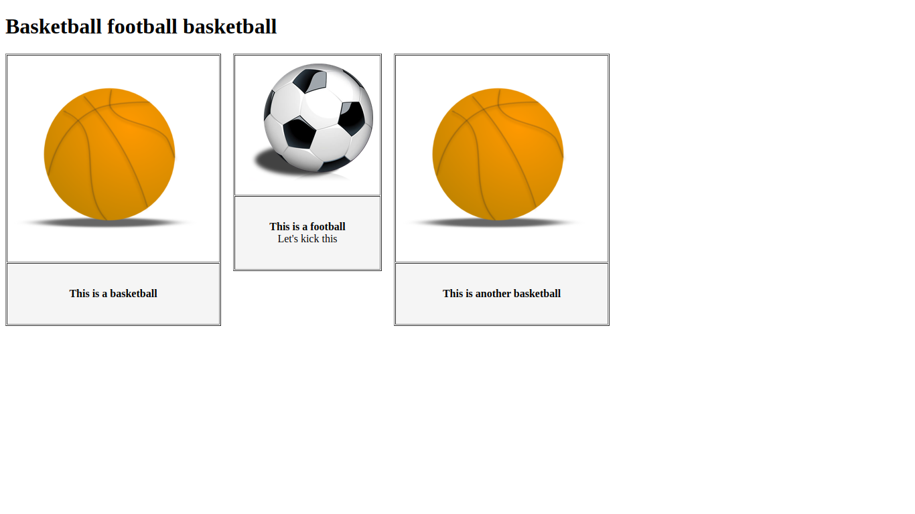

<!DOCTYPE html>

<html>

<head>

<title>Q3</title>

</head>

<body>

<main style = " height:200px; width:1366px;">

<style>main{background-image: url(stripe-hero-background-effect-html-css.png);}

</style>

<h1 style="text-align: center;">HTML is a language</h1>

<h2 style="text-align: center;">This is slightly smaller than above</h2>

<h3 style="text-align:center;">This is even smaller</h3>

<p style="text-align: center;">Hypertext markup language.</p>

</main>

<div style = " height:340px; width:340px; float:left; margin-left: 350px;">

<table border="1" cellspacing="1" cellpadding="2">

<tr>

<td align=left><b>&nbsp;<img src="unnamed.png"> &nbsp;</b></td>

</tr>

<tr>

<td align=center bgcolor=F5F5F5><b>&nbsp;<p>This is a basketball</p>&nbsp;</b></td>

</tr>

</table>

</div>

<div style = " height:340px; width:340px; float:left;">

<table border="1" cellspacing="1" cellpadding="2">

<tr>

<td align=left><b>&nbsp;<img src="unnamed.png"> &nbsp;</b></td>

</tr>

<tr>

<td align=center bgcolor=F5F5F5><b>&nbsp;<p>This is another basketball</p>&nbsp;</b></td>

</tr>

</table>

</div>

</div>

</body>

</html>

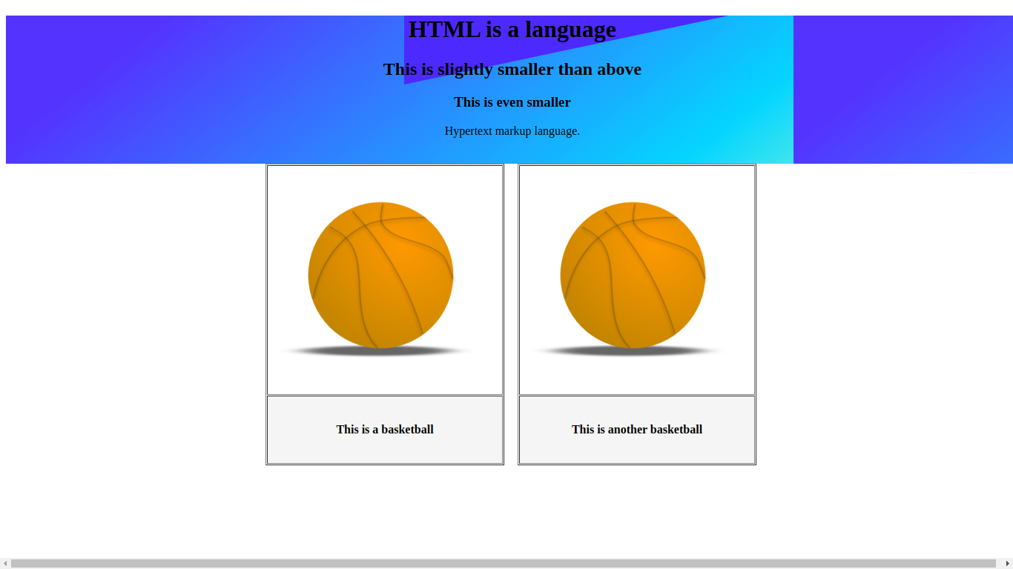

<html>

<head>

<title>Q4</title>

</head>

<body bgcolor=FFFFFF>

<h1>Planets</h1>

<table role="presentation" border="2" cellspacing="1" cellpadding="4">

<tr>

<td align=left><b>&nbsp;</b></td>

<td align=center><b>&nbsp;MERCURY&nbsp;</b></td>

<td align=center><b>&nbsp;VENUS&nbsp;</b></td>

<td align=center><b>&nbsp;EARTH&nbsp;</b></td>

<td align=center><b>&nbsp;MOON&nbsp;</b></td>

<td align=center><b>&nbsp;MARS&nbsp;</b></td>

<td align=center><b>&nbsp;JUPITER&nbsp;</b></td>

<td align=center><b>&nbsp;SATURN&nbsp;</b></td>

<td align=center><b>&nbsp;URANUS&nbsp;</b></td>

<td align=center><b>&nbsp;NEPTUNE&nbsp;</b></td>

</tr>

<tr>

<td align=left><b>Mass (10<sup>24</sup>kg)</b></td>

<td align=center>0.330</td>

<td align=center>4.87</td>

<td align=center>5.97</td>

<td align=center>0.073</td>

<td align=center>0.642</td>

<td align=center>1898</td>

<td align=center>568</td>

<td align=center>86.8</td>

<td align=center>102</td>

</tr>

<tr>

<td align=left><b>Diameter (km)</b></td>

<td align=center>4879</td>

<td align=center>12,104</td>

<td align=center>12,756</td>

<td align=center>3475</td>

<td align=center>6792</td>

<td align=center>142,984</td>

<td align=center>120,536</td>

<td align=center>51,118</td>

<td align=center>49,528</td>

</tr>

<tr>

<td align=left><b>Density (kg/m<sup>3</sup>)</b></td>

<td align=center>5427</td>

<td align=center>5243</td>

<td align=center>5514</td>

<td align=center>3340</td>

<td align=center>3933</td>

<td align=center>1326</td>

<td align=center>687</td>

<td align=center>1271</td>

<td align=center>1638</td>

</tr>

</table>

</body>

</html>

